--q1----------

create view q1 as

select d.dnumber,d.dname,avg(e.salary) avgSalary

from employee e join department d on e.dno = d.dnumber

group by d.dnumber,d.dname

select top 1 q1.dnumber,q1.dname,q1.avgSalary

from q1

order by q1.avgSalary desc



--q2----------

select w.essn,w.pno,w.hours

from works_on w

group by w.essn,w.pno,w.hours

having w.hours >= All(

select avg(works_on.hours)

from works_on

)

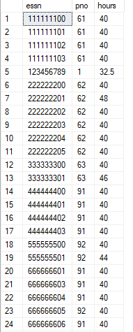

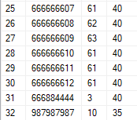

--q3----------

select d.dname

from department d join employee e on e.dno = d.dnumber

except

select d.dname

from department d join employee e on e.dno = d.dnumber

where not exists (

select *

from works_on w

where w.essn = e.ssn

)

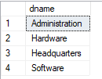

--q4----------

select e.fname,e.lname

from department d join employee e on d.mgrssn = e.ssn

where exists(

select *

from dependent de

where de.essn = d.mgrssn and de.relationship = 'Spouse'

)

except

select e.fname,e.lname

from department d join employee e on d.mgrssn = e.ssn

where d.mgrssn in(

select de.essn

from dependent de

where de.essn = d.mgrssn and de.relationship = 'Son' or de.relationship = 'Daughter'

)



--question 1 part b

create view depManagers as

select d.mgrssn,e.fname,d.dnumber,d.dname

from employee e join department d on e.ssn = d.mgrssn

create view supervisors as

select distinct s.ssn,s.fname

from employee e join employee s on e.superssn = s.ssn

create view partb as

select e.ssn employeeSSN,e.fname employeeName,d.dname,d.fname mgrName,s.fname supervisorName

from employee e left join depManagers d on e.dno = d.dnumber left join supervisors s on e.superssn = s.ssn

select * from partb

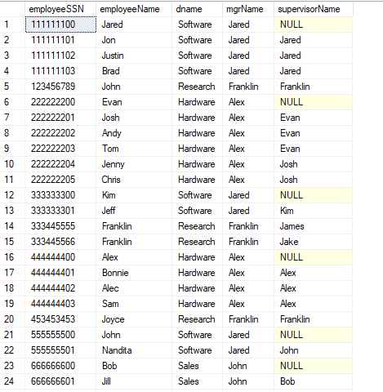

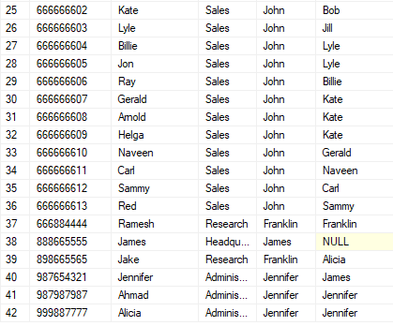

--q2parta

create table empPhoneNumbers(

empssn char(9),

phoneNumber char(11),

primary key(empssn,phoneNumber),

FOREIGN KEY (empssn) REFERENCES employee(ssn) on update cascade on delete cascade

)

insert into empPhoneNumbers values ('987654321','03000000000');

insert into empPhoneNumbers values ('987654321','03000000100');

select * from empPhoneNumbers;

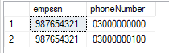

--q2partb

create table payroll(

payroll_id int,

essn char(9),

salary int,

bonuses int,

primary key(payroll_id),

FOREIGN KEY (essn) REFERENCES employee(ssn) on update cascade on delete cascade

)

insert into payroll values (1,'987654321',50000,5000);

select * from payroll;

